**This document explains the project and project management below:**

**Project details**

The project has login UI in index.html

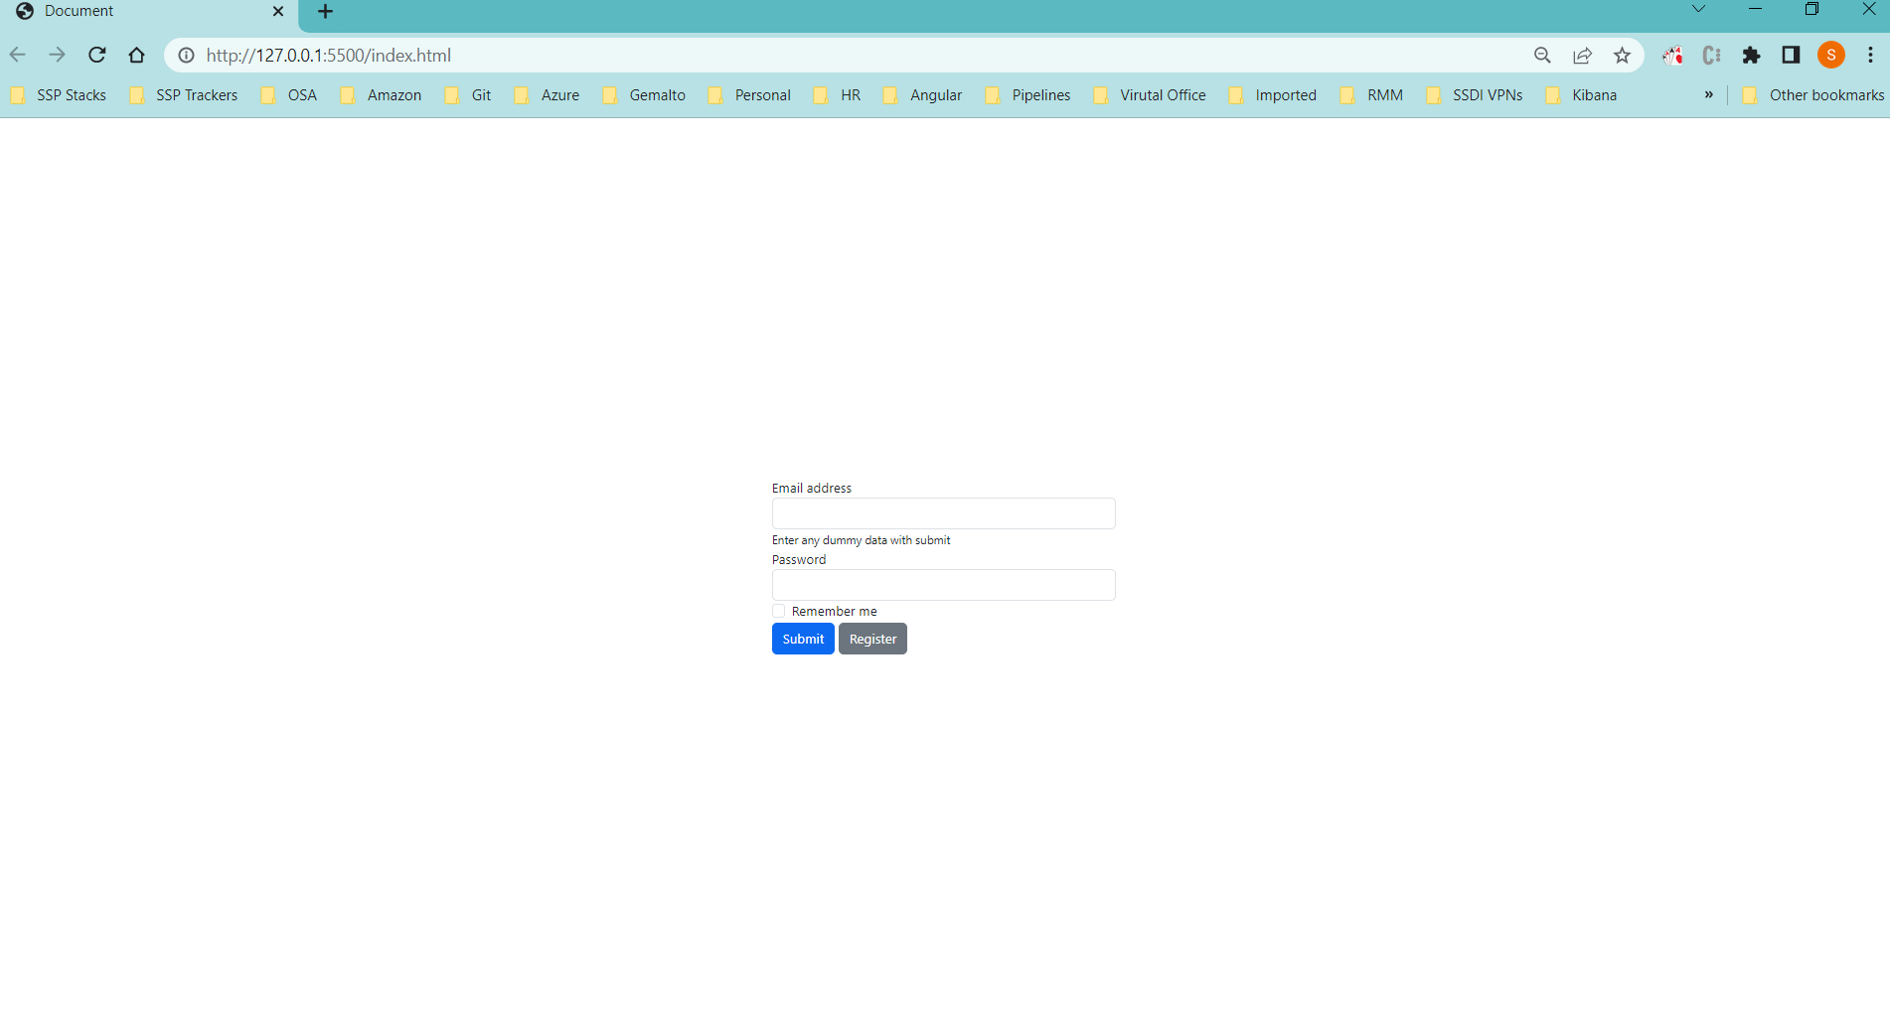

After login with any dummy data you will see the blog page in blog.html.

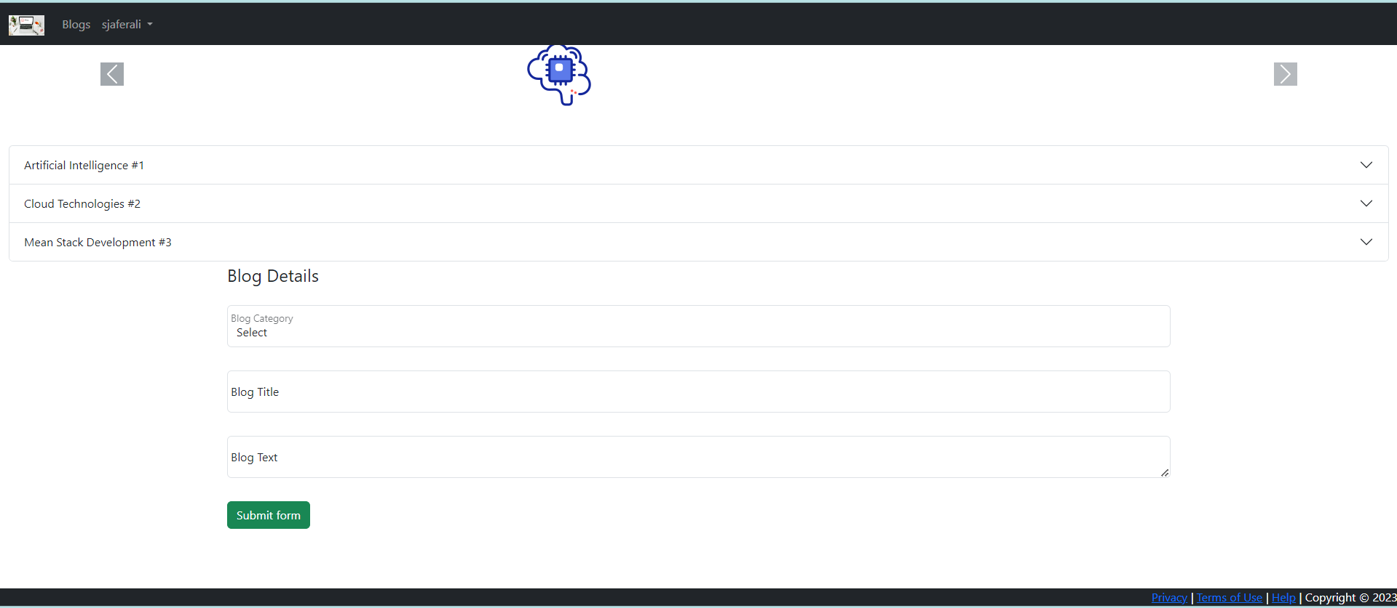

The blog page has the following

1. Header
2. Footer
3. The Carousal of topics on top
4. The blog topics Artificial Intelligence, Cloud Technologies and Mean Stack development use the accordion component
5. The data in the respective topics is populated dynamically from data files

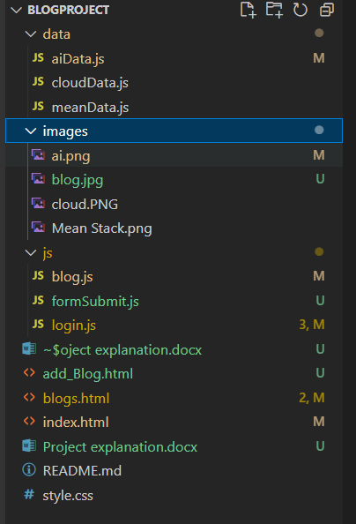

Below is auto populated items from aiData.js

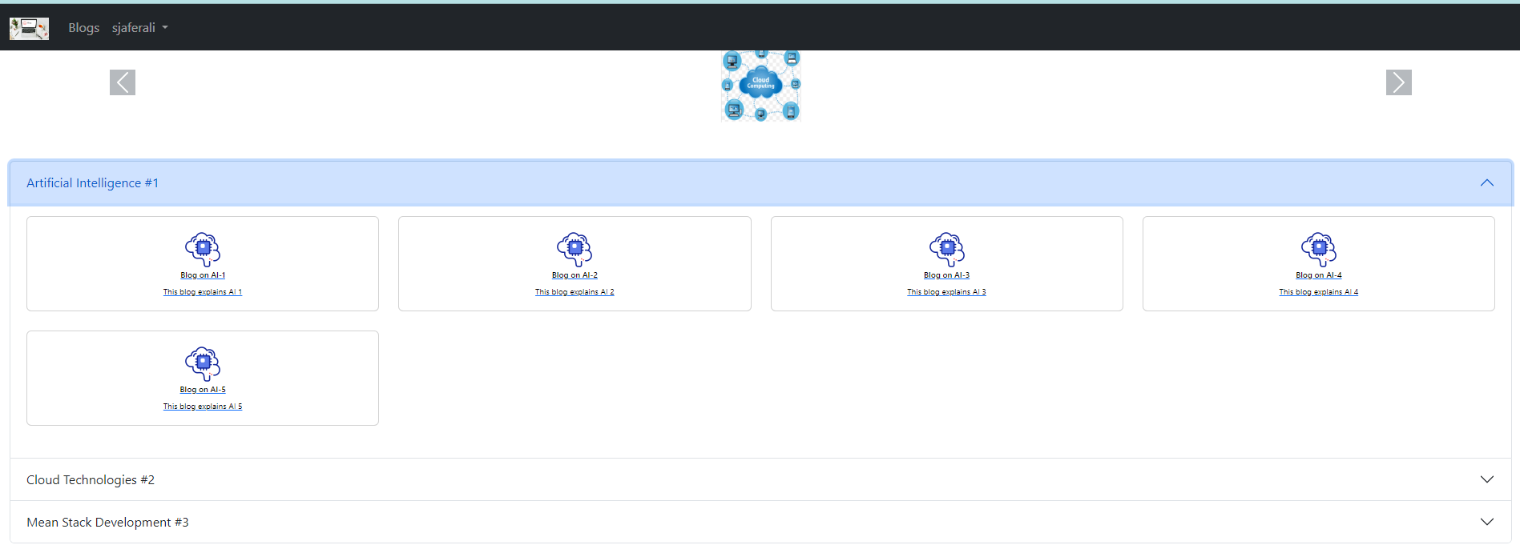

The new blog can be added using the form below:

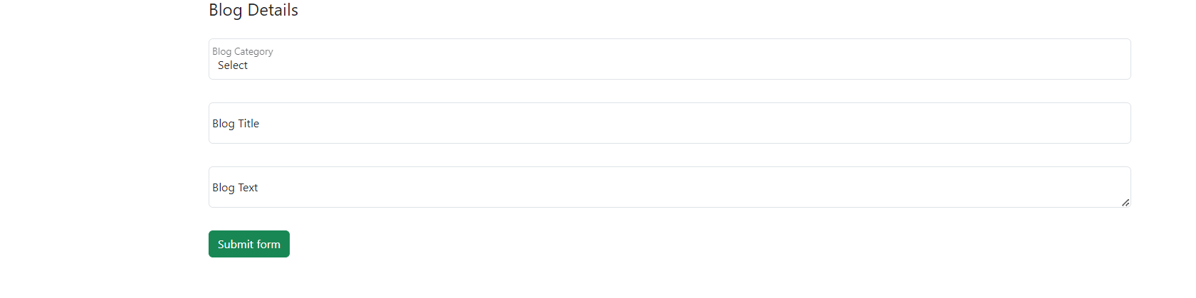

You can select the blog category and then write the blog and submit

On Submit the respective category in accordion is populated as below

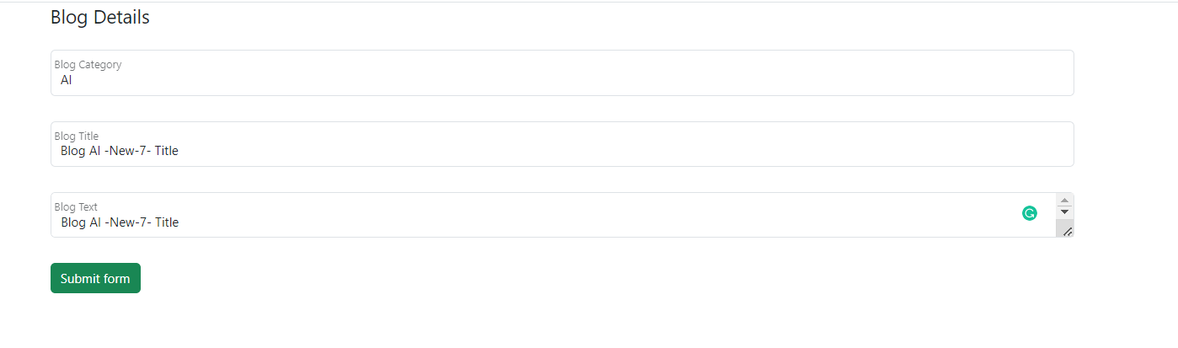

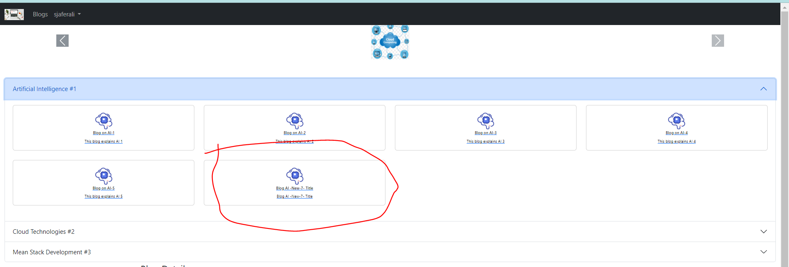

**Project Management:**

1. The project is managed using Agile Methodology-Scrum
2. The tool used for project management is JIRA
3. The JIRA dashboard has Release cycles with date and Sprints with start and end date
4. Epics and stories are created in JIRA
5. The Epics are at higher level like As a User I need sign up and login mechanism
6. Some of the story example for above
7. As a User I want to Sign up to the blogging system with Name, email id, address and phone number
8. As a User I want to login to the blogging system with user name and password. I also want me to be remembered in the system. The password should be of minimum 8 characters.
9. After story creation, we need to update the story points based on the size of story.
10. We need to update the estimated time and remaining time
11. The remaining time needs update daily to monitor the burn down chart of hours.
12. We will also monitor the burn down chart of Story points
13. The burn down chart will indicate whether the sprint is on schedule or delayed.
14. This daily standup happens to with three questions of achievement yesterday, todays task and blockers
15. Blockers are noted down and separate discussion is done with blockers